LS Parents’ Night Out Event
Sponsored by Panther Club

Whether you have errands to run or would like a night to yourself, we’ve got you covered!
Drop off the kids and enjoy a Parents’ Night Out!

When: Thursday, December 9, 2021 from 6:00PM – 8:00PM
Where: Family Commons
Who: All Lower School Students
What: We will enjoy a pizza dinner, watch a movie (Lego Star Wars: Holiday Special, rated TV-Y7), decorate cookies and do a winter themed craft!
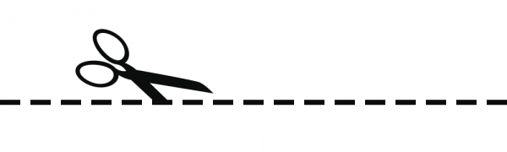
Cost: $12.00 Per Child
*See back for drop-off and pick-up protocols

Parent’s Night Out
Return to LS office by Thursday December 2, 2021

Student Name_____________________________________ Grade________
Parent Name___________________________________ Phone_________________
Health/Allergy Concerns_______________________________________________________
Emergency Contact Name __________________________ Phone_________________
Cost: $12.00 _____ Check (Payable to Mounds Park Academy) _____ Cash

Drop-off and Pick-up Procedures:
- At 6:00PM Staff will meet families at Door 1 (LS Main Entrance) to check in and conduct standard health checks.
- Staff will then bring students to family commons for the event.
- Students attending after school Panther club until 6:00PM will be escorted to the event.
- Pick-up will be at Door 1 (LS Main Entrance) at 8:00PM
If you would like to pick-up your child early or need to contact us please call (651)748-5571

